
System Setup – Installing/Updating and Setting Up Windows 11 Environment

Rui Zhao, CCNA
Importance:
The installation/update and setting up Windows 11 is important because it resolves troublesome system errors, improves security by mandating Trusted Platform Module (TPM) 2.0 and secure boot, and promote overall stability for consumer use. This guide will also provide the necessary applications to set up like Office 365 and will also demonstrate setting up optional technical setups like PuTTY and NVIDIA drivers.

Background Information:
Windows 11, released on October 5, 2021, surfaced as the successor to Windows 10 (2015). The transition of Windows 10 to Windows 11 is available for free for devices that meet the prerequisites for transitions into Windows 11.

For requirements, the device must meet standard prerequisites that include a performative CPU, at least 4 GB of ram, 64 GB of storage, Unified Extensible Firmware Interface (UEFI) and Secure Boot capable, Trusted Platform Module (TPM) version 2.0, and graphics card compatible with DirectX 12 or later with WDDM 2.0 driver. For additional details including a list of approved CPUs along with other details regarding prerequisites of the Windows 11 transition, please visit https://support.microsoft.com/en-us/windows/windows-11-system-requirements-86c11283-ea52-4782-9efd-7674389a7ba3.

A consumer may also decide to perform a wipe, which utilizes the same process as installing or updating to Windows 11 with reasons not limited to clearing viruses, clean installation or wiping, reinstalling drivers, and clearing corruption on your device.

A tool for Windows 11 installation is the usage of USB drives. Rufus, utility for formatting and creating bootable flash drives, is especially used when you need to create USB installation media from Bootable ISOs like Windows, Linux, UEFI, etc. This process of installation is a simplification to the process of transferring ISO images from OS onto USB devices.

With the new Windows 11 installation as opposed to previous versions, Windows 11 has additional security features and other features such as realignment of start buttons, additional Copilot support, additional quick settings customization, repurposed widgets, window layout snapping, revamped file explorer with the addition of tabs, better customization, better performance, etc. However, it is important to note that many of these features can be reverted to their previous versions like realigning the start menu from center back to left.

Do note that while Windows 11 seems to have many more features than Windows 10, the expected difference is much less. However, Windows 10 support is ending on October 14, 2025, and it is advised to upgrade to Windows 11 whenever possible with the user’s device if the device meets the prerequisites for upgrading. With Windows 10 support ending, Microsoft will no longer provide any Windows 10 update from Windows Update, which may cause security issues and vulnerabilities. It will also cut off technical assistance and additional security fixes. Please move onto Windows 11 whenever possible. Do note that you can get a one-year extended security update for $30 for Windows 10 devices that cannot upgrade to Windows 11 or do not wish to.

The Windows 11 Media Creation Tool is a downloadable tool that can be utilized for the purpose of installment of Windows 11. It creates a retail image of Windows 11. By placing Windows 11 Media Creation Tool into a USB or DVD, a consumer may boot the flash drive and enter the procedure to install or upgrade to Windows 11 with demonstrated steps below.

The Office 365 (or Microsoft 365) app is a Microsoft owned product that is a cloud-powered productivity platform. Within Office 365, various familiar applications are packaged: Word, PowerPoint, Excel, Teams, OneDrive, Outlook, OneNote, etc. Regarding pricing details, please visit https://www.microsoft.com/en-us/microsoft-365/buy/compare-all-microsoft-365-products-b.

Nvidia Drivers enables your computer and graphic processor to communicate and ensures that hardware works with the latest software such as games or other applications. Outdated drivers could cause unexpected crashes or applications failing to launch. Additionally, outdated/vulnerable drivers in general could also promote the increase in possibility for malware and ransomware.

For technical profession or if an individual wants to control remote systems, the app PuTTY. PuTTY allows connecting devices with safe protocols like secure socket shell (SSH), Telnet, login, etc. PuTTY acts as a terminal program for windows. Using PuTTY can help with session management, customizing features like managing routers and switches, and allow access to serial ports.

Lab Summary:

In this lab, we will install Windows 11 using a USB stick for booting. We will also be wiping our hard drives via deleting partitions to free space. We then will install any useful applications that are used or essential like Microsoft 365 and Nvidia drivers.

Configuration Requirements:

-Necessary Windows 11 hardware prerequisites https://support.microsoft.com/en-us/windows/windows-11-system-requirements-86c11283-ea52-4782-9efd-7674389a7ba3.
-USB Stick of at least 8 Gb in storage

Lab Commands:

Make sure you are planning to either upgrade, install, or wipe your device. Have your USB plugged in your device through the USB connector. Head over to https://www.microsoft.com/en-us/software-download/windows11.

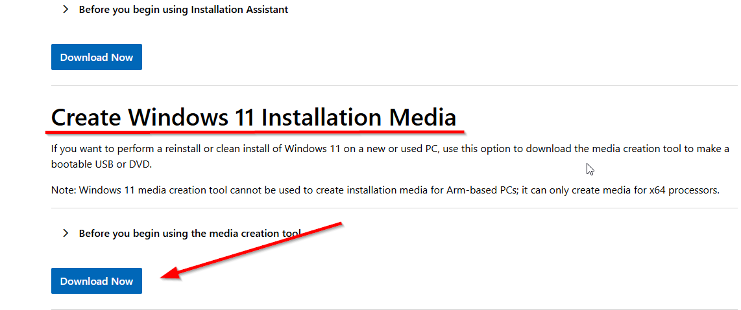

In your download history depending on your browser (in this case chrome), you should see mediacreationtool.exe. Click and go into the tool.

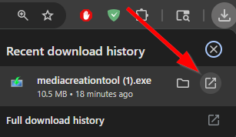

After entering the Media Creation Tool, accept the terms and conditions after reading it. Go through the setup and choose USB flash drive. Note: The USB stick should be already plugged into your device through the USB connector. Make sure to select USB flash drive then hit next.
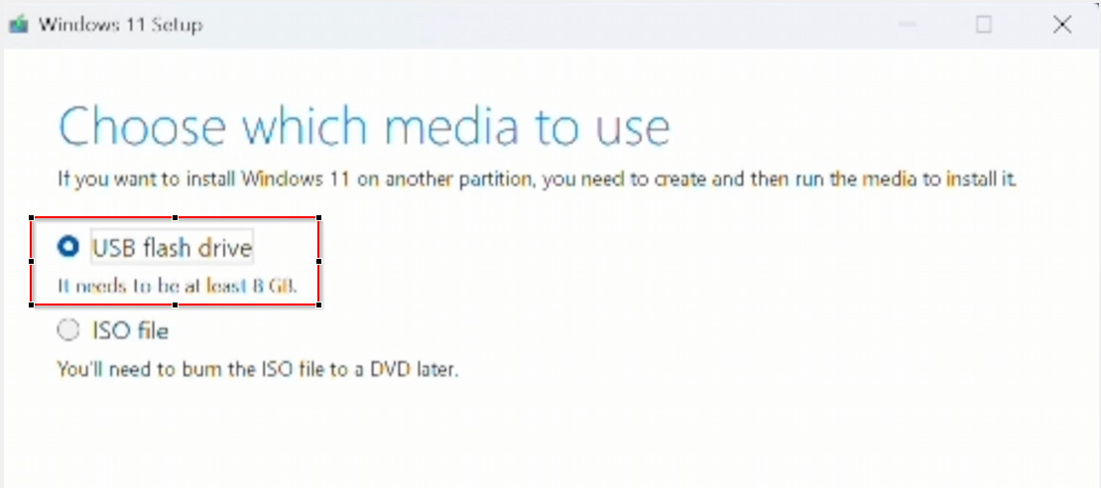

Next, select your USB stick that is plugged in and press next. Note: USB must be at least 8 Gb of storage.

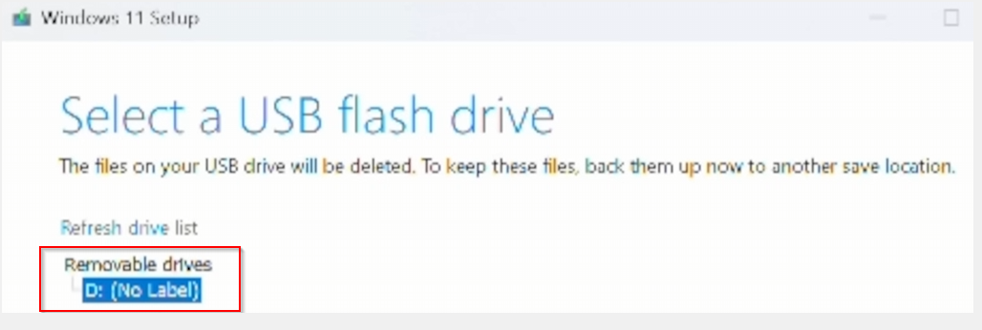

Reboot your device with USB attached. When booting up, press the PC’s boot key (commonly F12, F9, Esc, F2, Del. It varies by manufacturer). Then, locate the boot menu and select your USB drive. Note: Figure shown may not be the same as your device. Interfaces could look different depending on your motherboard. On the bright side, every interface would have a boot menu.
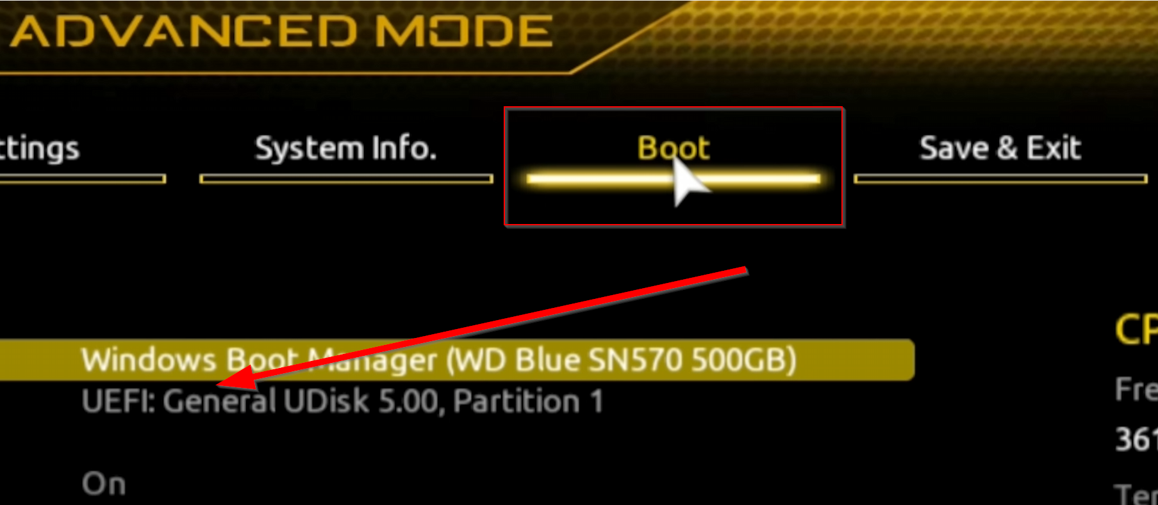
After USB selection, you will have reached the Windows Setup menu. Follow the steps by Windows. Note: if it is your first time installing Windows, you need to enter your product key. Else, you can select “I don’t have a product key.”

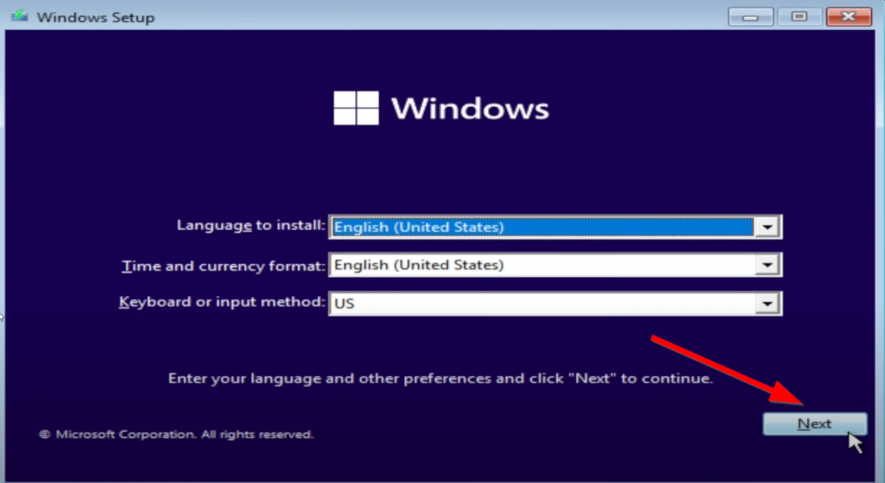

After following through, you will reach the partition screen. Select which partition to install Windows 11 on. (For people performing a wipe, if you want to fully wipe your device, select all of the partitions that can be deleted and delete them all.)

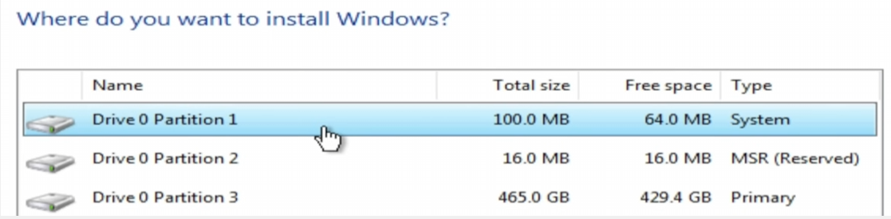

After you have finished installing, you will be met with the “Is this the right country or region” screen. Follow through the steps as described by Microsoft. Go ahead and sign in to your Microsoft account.

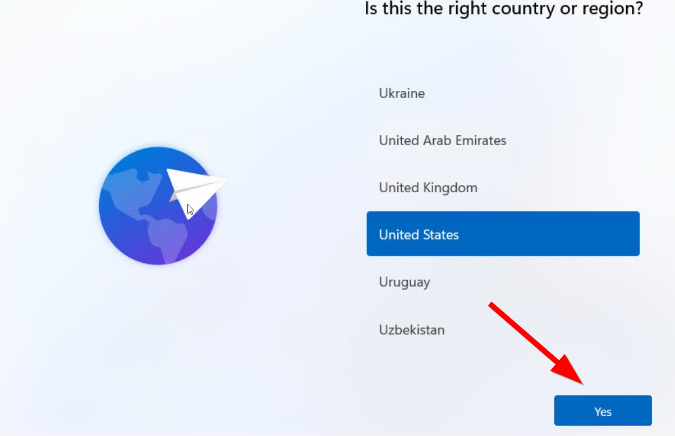

After finishing, you can take out the USB stick. Congratulations, your Windows 11 installation should be finished installing.

Microsoft 365 Installation:

After setting up Windows 11, here are some recommended applications to be installed onto the device. Office 365, or Microsoft 365 is an extremely useful tool for working productively and creatively. Go to this link and sign in with your Microsoft details: https://www.microsoft.com/en-us/microsoft-365/download-office. Click Download for Windows.

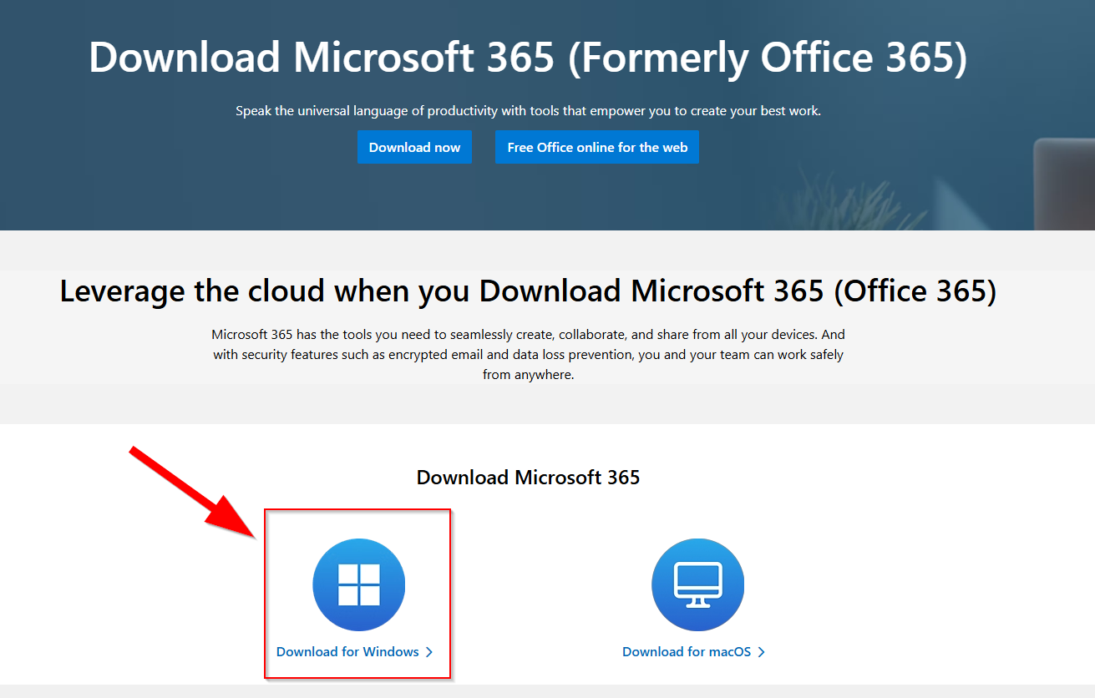

Open up OfficeSetup.exe

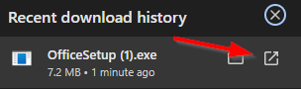

Wait till Microsoft 365 finishes downloading.

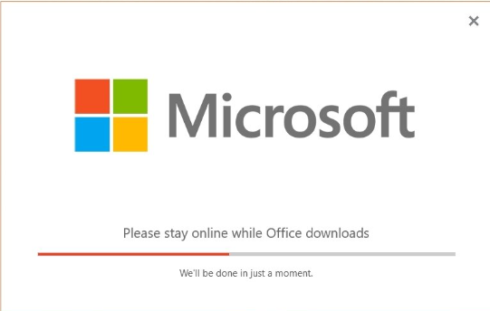

Congratulations! You have installed Microsoft 365.

Nvidia Drivers Installation:

Head over to https://www.nvidia.com/en-us/geforce/drivers/. Click on Download Now.
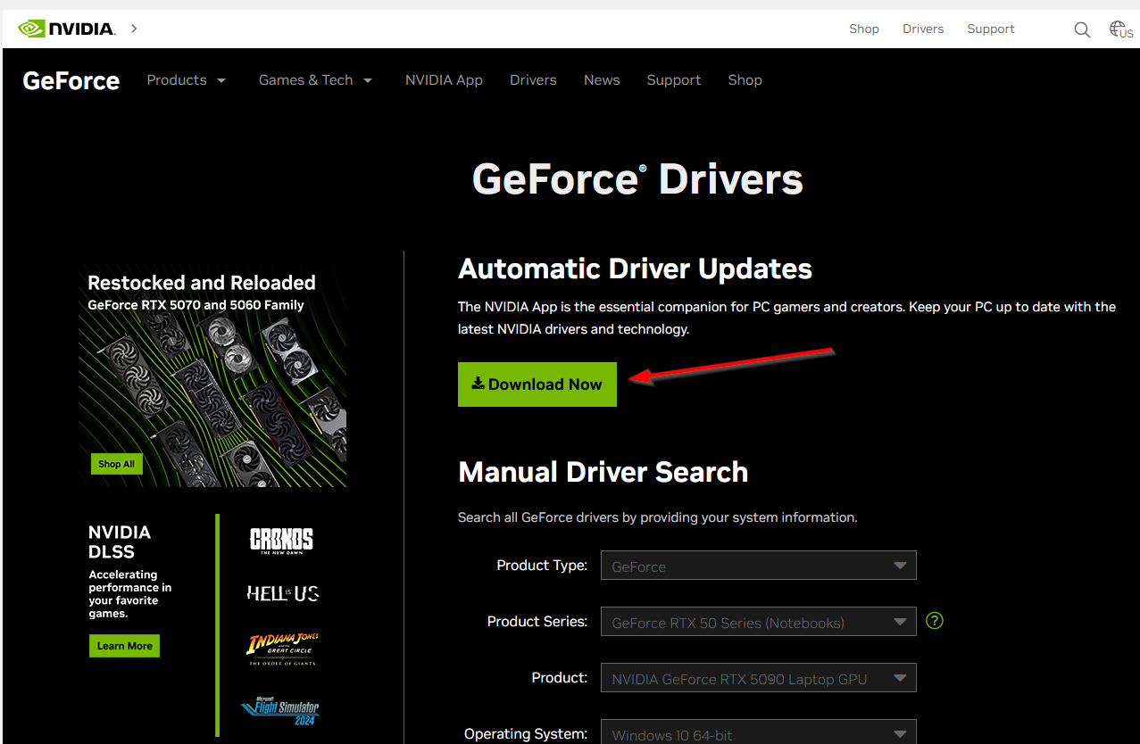
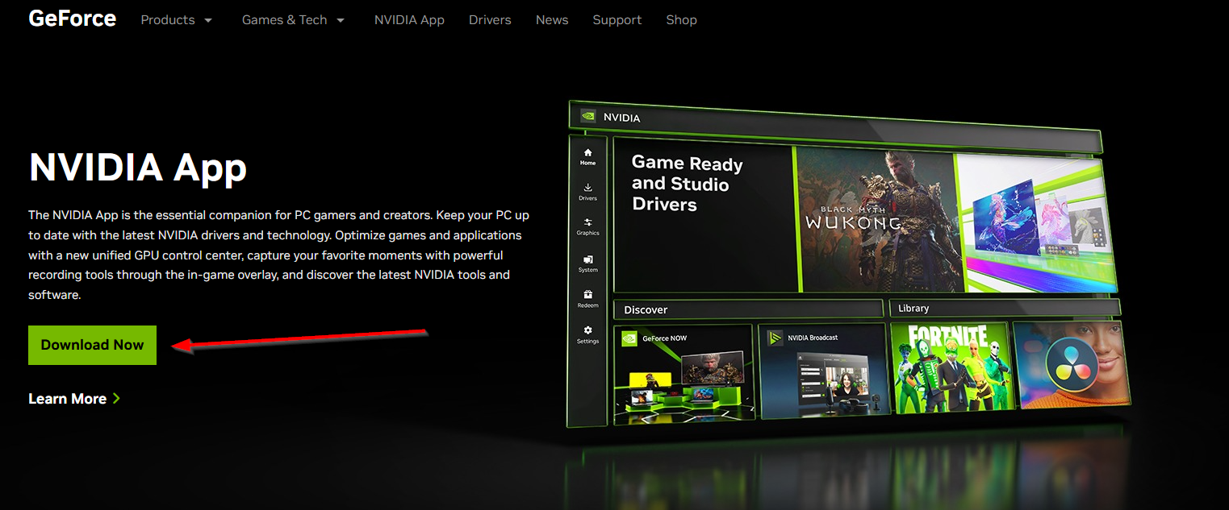

Open up the installation from downloads. Load the NVIDIA App.

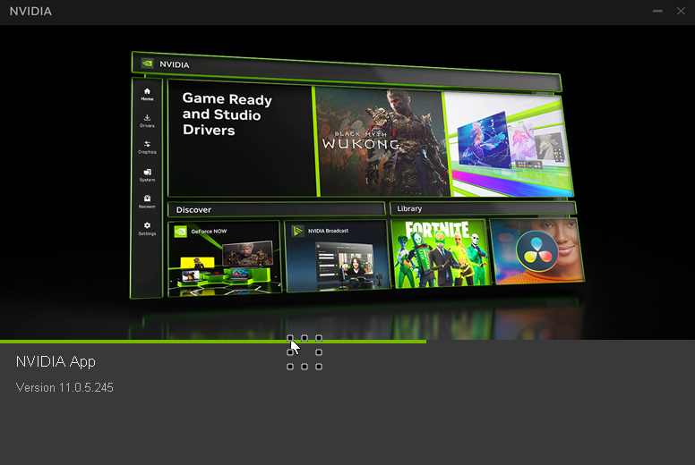

Select AGREE & CONTINUE

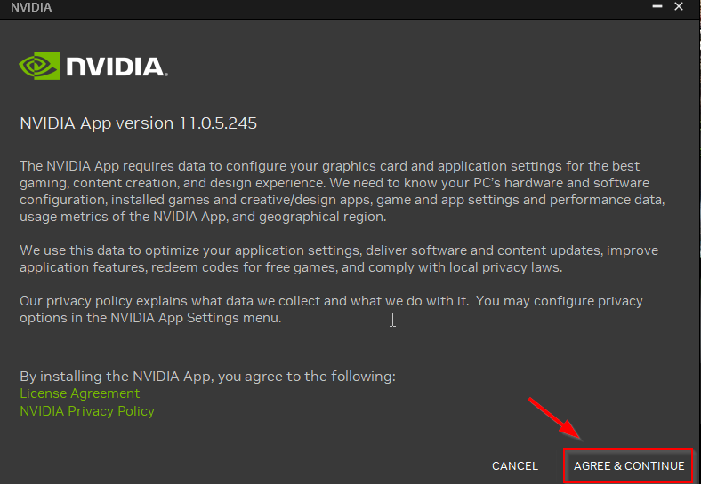

Note: It may require you to sign in. Follow the instructions to make an account if asked. Then, navigate to the Drivers tab.

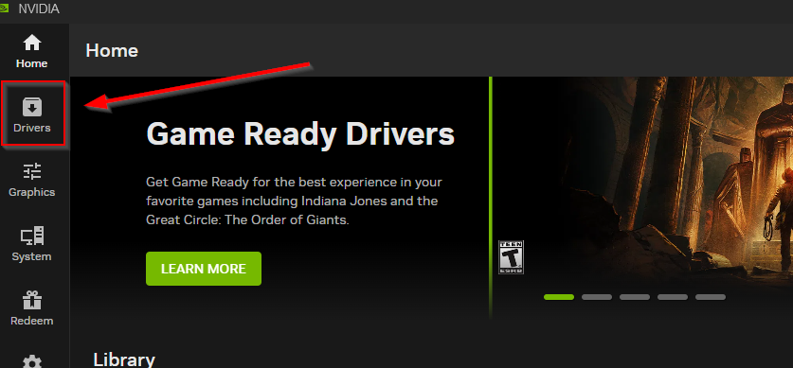

If you never had Nvidia drivers, click Download, then Install.

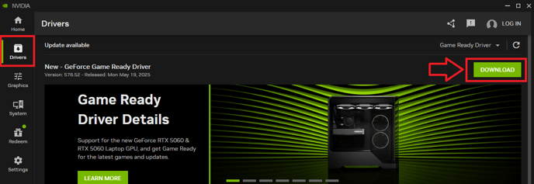

Select Express installation and hit CONTINUE.

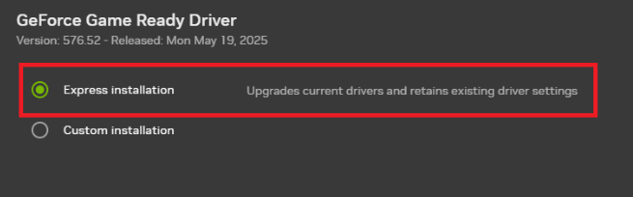

Your device may need to restart during or after the installation. When the entire installation is done after restarting, it will look like this.

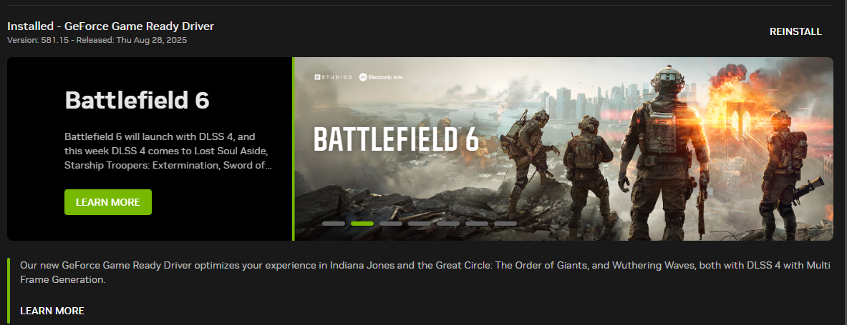

Congratulations, you have installed Nvidia Drivers.

PuTTY installation:

Head over to https://www.chiark.greenend.org.uk/~sgtatham/putty/. Click on Download it here.

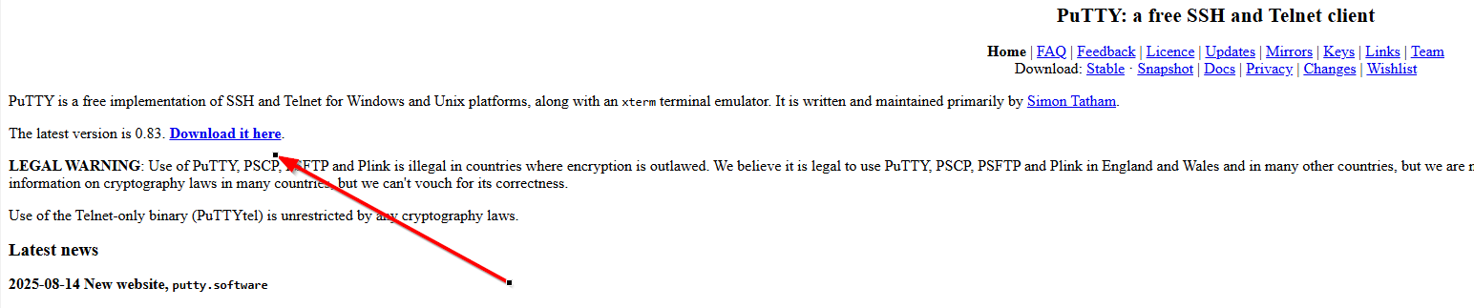

Select 64-bit x86 and click on the hyperlink.

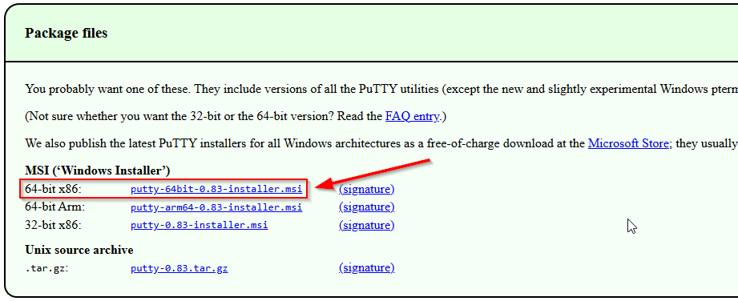

Open the application and follow the instructions.

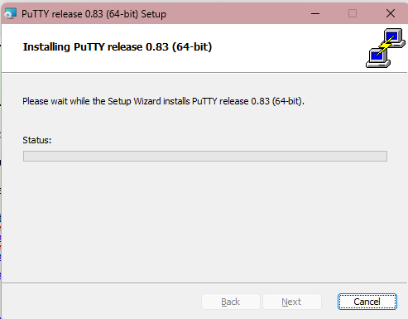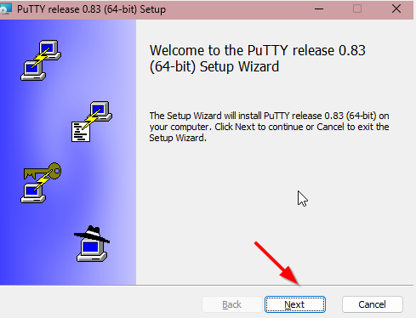
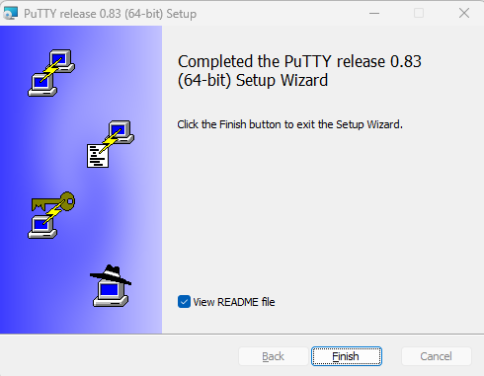

After the installation, search up PuTTY in your windows tab. It should be there.

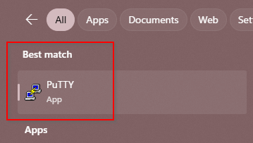

Congratulations, you have installed PuTTY.

Problems:

By how Windows structure was created, screenshots of screens like Windows Setup menu cannot be taken. We also had a bootable flash drive available for immediate use, which limited further experimental screenshots. My device has already installed many of the products, so reinstalling these products would mean getting a different interface.

These errors were fixed by finding other sources to use in place for screenshots I cannot attain myself. I’ve traced the steps to creating a bootable flash drive.

Conclusion:

The Windows 11 installation may seem confusing for the average person to understand. After experimenting with the installation along with the installation of a few other products, namely Microsoft 365 and drivers, I’ve revisited the knowledge of setting up my environment. During background research, I’ve also learned about Windows Updates and Windows 11 prerequisites.

